

Muhammad Rizqi Nur Ikhsannudin

R3/C

1. Single 1

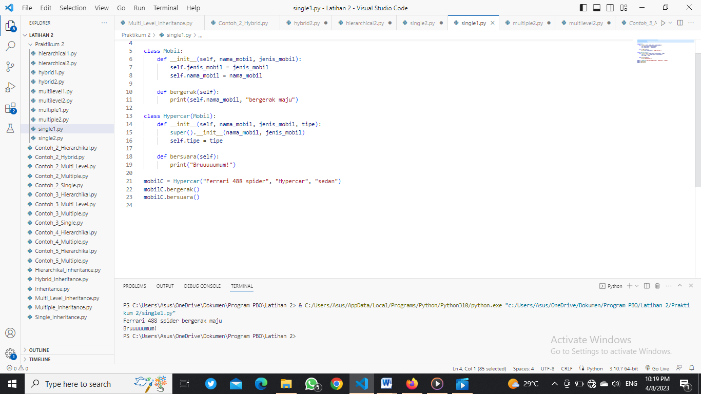

#Nama   : Muhammad Rizqi Nur Ikhsannudin

#Nim    : 210511100

#Kelas  : R3/TIF21C

class Mobil:

    def __init__(self, nama_mobil, jenis_mobil):

        self.jenis_mobil = jenis_mobil

        self.nama_mobil = nama_mobil

    def bergerak(self):

        print(self.nama_mobil, "bergerak maju")

class Hypercar(Mobil):

    def __init__(self, nama_mobil, jenis_mobil, tipe):

        super().__init__(nama_mobil, jenis_mobil)

        self.tipe = tipe

    def bersuara(self):

        print("Bruuuuumum!")

mobilC = Hypercar("Ferrari 488 spider", "Hypercar", "sedan")

mobilC.bergerak()

mobilC.bersuara()

1. Single 2

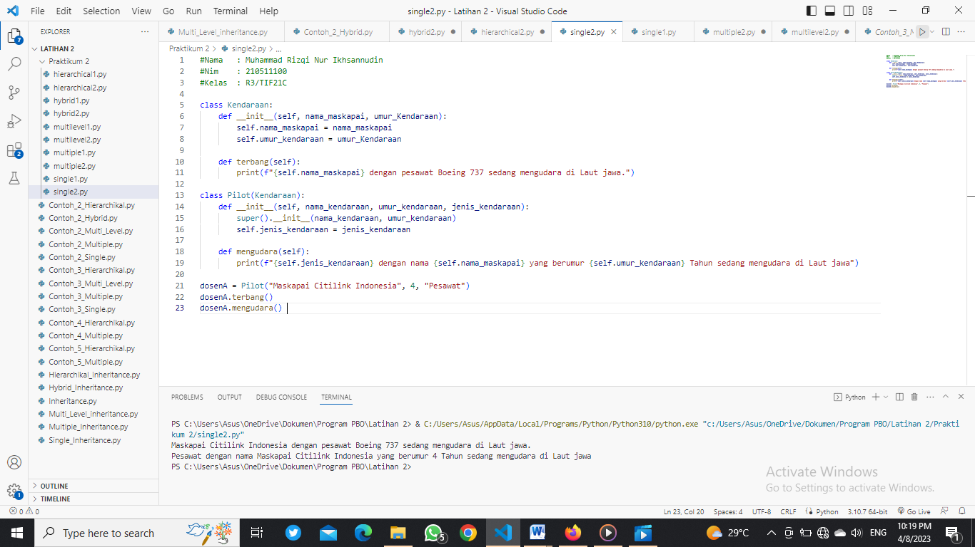

#Nama   : Muhammad Rizqi Nur Ikhsannudin

#Nim    : 210511100

#Kelas  : R3/TIF21C

class Kendaraan:

    def __init__(self, nama_maskapai, umur_Kendaraan):

        self.nama_maskapai = nama_maskapai

        self.umur_kendaraan = umur_Kendaraan

    def terbang(self):

        print(f"{self.nama_maskapai} dengan pesawat Boeing 737 sedang mengudara di Laut jawa.")

class Pilot(Kendaraan):

    def __init__(self, nama_kendaraan, umur_kendaraan, jenis_kendaraan):

        super().__init__(nama_kendaraan, umur_kendaraan)

        self.jenis_kendaraan = jenis_kendaraan

    def mengudara(self):

        print(f"{self.jenis_kendaraan} dengan nama {self.nama_maskapai} yang berumur {self.umur_kendaraan} Tahun sedang mengudara di Laut jawa")

dosenA = Pilot("Maskapai Citilink Indonesia", 4, "Pesawat")

dosenA.terbang()

dosenA.mengudara()

1. Multiple 1

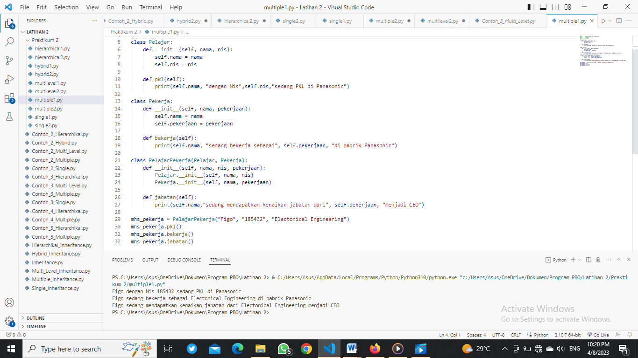

#Nama   : Muhammad Rizqi Nur Ikhsannudin

#Nim    : 210511100

#Kelas  : R3/TIF21C

class Pelajar:

    def __init__(self, nama, nis):

        self.nama = nama

        self.nis = nis

    def pkl(self):

        print(self.nama, "dengan Nis",self.nis,"sedang PKL di Panasonic")

class Pekerja:

    def __init__(self, nama, pekerjaan):

        self.nama = nama

        self.pekerjaan = pekerjaan

    def bekerja(self):

        print(self.nama, "sedang bekerja sebagai", self.pekerjaan, "di pabrik Panasonic")

class PelajarPekerja(Pelajar, Pekerja):

    def __init__(self, nama, nis, pekerjaan):

        Pelajar.__init__(self, nama, nis)

        Pekerja.__init__(self, nama, pekerjaan)

    def jabatan(self):

        print(self.nama,"sedang mendapatkan kenaikan jabatan dari", self.pekerjaan, "menjadi CEO")

mhs_pekerja = PelajarPekerja("Figo", "185432", "Electonical Engineering")

mhs_pekerja.pkl()

mhs_pekerja.bekerja()

mhs_pekerja.jabatan()

1. Multiple 2

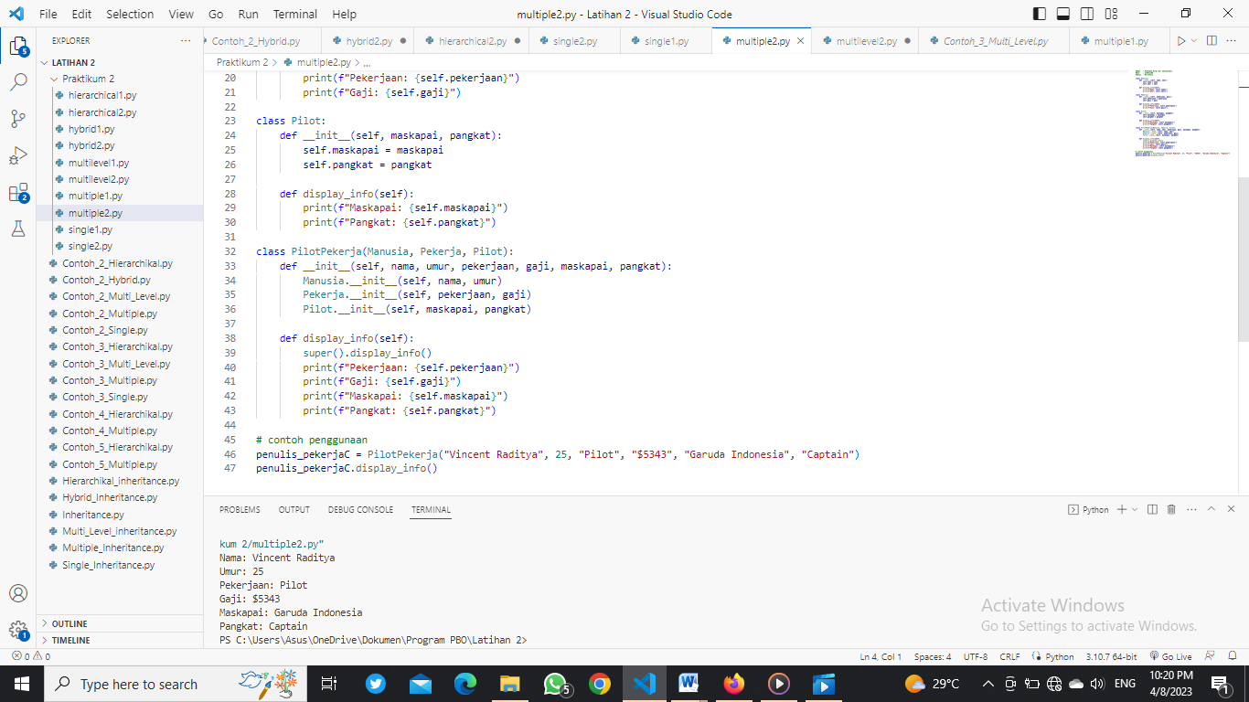

#Nama   : Muhammad Rizqi Nur Ikhsannudin

#Nim    : 210511100

#Kelas  : R3/TIF21C

class Manusia:

    def __init__(self, nama, umur):

        self.nama = nama

        self.umur = umur

    def display_info(self):

        print(f"Nama: {self.nama}")

        print(f"Umur: {self.umur}")

class Pekerja:

    def __init__(self, pekerjaan, gaji):

        self.pekerjaan = pekerjaan

        self.gaji = gaji

    def display_info(self):

        print(f"Pekerjaan: {self.pekerjaan}")

        print(f"Gaji: {self.gaji}")

class Pilot:

    def __init__(self, maskapai, pangkat):

        self.maskapai = maskapai

        self.pangkat = pangkat

    def display_info(self):

        print(f"Maskapai: {self.maskapai}")

        print(f"Pangkat: {self.pangkat}")

class PilotPekerja(Manusia, Pekerja, Pilot):

    def __init__(self, nama, umur, pekerjaan, gaji, maskapai, pangkat):

        Manusia.__init__(self, nama, umur)

        Pekerja.__init__(self, pekerjaan, gaji)

        Pilot.__init__(self, maskapai, pangkat)

    def display_info(self):

        super().display_info()

        print(f"Pekerjaan: {self.pekerjaan}")

        print(f"Gaji: {self.gaji}")

        print(f"Maskapai: {self.maskapai}")

        print(f"Pangkat: {self.pangkat}")

# contoh penggunaan

penulis_pekerjaC = PilotPekerja("Vincent Raditya", 25, "Pilot", "$5343", "Garuda Indonesia", "Captain")

penulis_pekerjaC.display_info()

1. Hierarchical 1

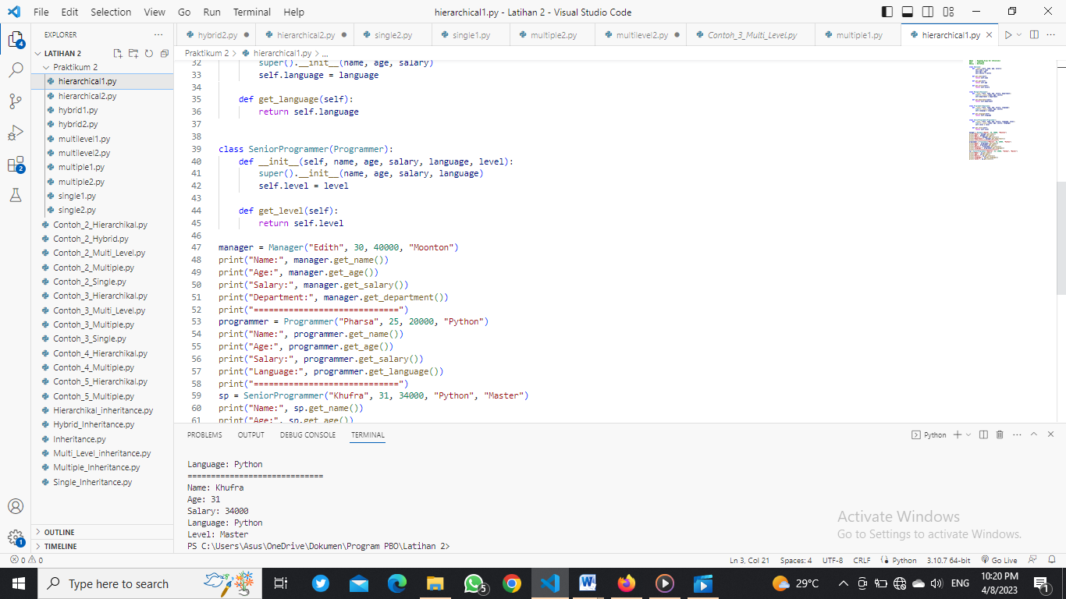

#Nama   : Muhammad Rizqi Nur Ikhsannudin

#Nim    : 210511100

#Kelas  : R3/TIF21C

class Employee:

    def __init__(self, name, age, salary):

        self.name = name

        self.age = age

        self.salary = salary

    def get_name(self):

        return self.name

    def get_age(self):

        return self.age

    def get_salary(self):

        return self.salary

class Manager(Employee):

    def __init__(self, name, age, salary, department):

        super().__init__(name, age, salary)

        self.department = department

    def get_department(self):

        return self.department

class Programmer(Employee):

    def __init__(self, name, age, salary, language):

        super().__init__(name, age, salary)

        self.language = language

    def get_language(self):

        return self.language

class SeniorProgrammer(Programmer):

    def __init__(self, name, age, salary, language, level):

        super().__init__(name, age, salary, language)

        self.level = level

    def get_level(self):

        return self.level

manager = Manager("Edith", 30, 40000, "Moonton")

print("Name:", manager.get_name())

print("Age:", manager.get_age())

print("Salary:", manager.get_salary())

print("Department:", manager.get_department())

print("=============================")

programmer = Programmer("Pharsa", 25, 20000, "Python")

print("Name:", programmer.get_name())

print("Age:", programmer.get_age())

print("Salary:", programmer.get_salary())

print("Language:", programmer.get_language())

print("=============================")

sp = SeniorProgrammer("Khufra", 31, 34000, "Python", "Master")

print("Name:", sp.get_name())

print("Age:", sp.get_age())

print("Salary:", sp.get_salary())

print("Language:", sp.get_language())

print("Level:", sp.get_level())

1. Hierarchical 2

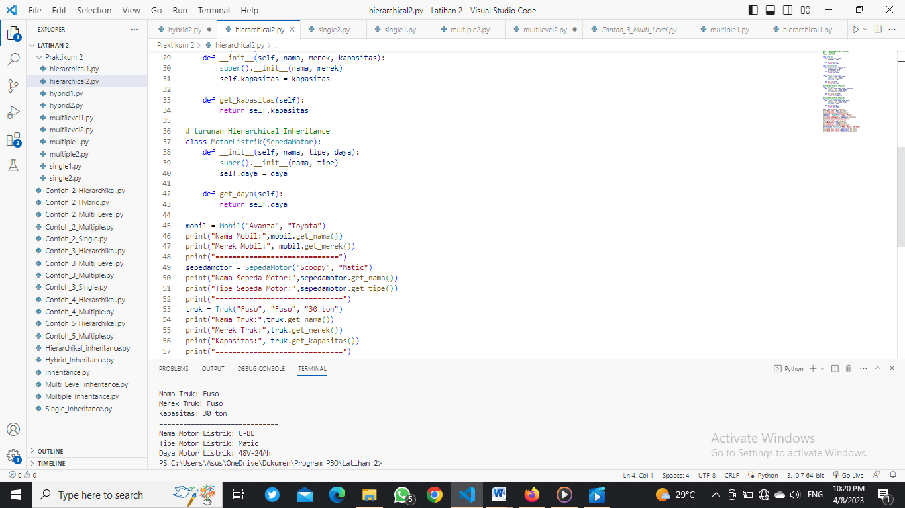

#Nama   : Muhammad Rizqi Nur Ikhsannudin

#Nim    : 210511100

#Kelas  : R3/TIF21C

class Kendaraan:

    def __init__(self, nama):

        self.nama = nama

    def get_nama(self):

        return self.nama

class Mobil(Kendaraan):

    def __init__(self, nama, merek):

        super().__init__(nama)

        self.merek = merek

    def get_merek(self):

        return self.merek

class SepedaMotor(Kendaraan):

    def __init__(self, nama, tipe):

        super().__init__(nama)

        self.tipe = tipe

    def get_tipe(self):

        return self.tipe

# turunan Hierarchical Inheritance

class Truk(Mobil):

    def __init__(self, nama, merek, kapasitas):

        super().__init__(nama, merek)

        self.kapasitas = kapasitas

    def get_kapasitas(self):

        return self.kapasitas

# turunan Hierarchical Inheritance

class MotorListrik(SepedaMotor):

    def __init__(self, nama, tipe, daya):

        super().__init__(nama, tipe)

        self.daya = daya

    def get_daya(self):

        return self.daya

mobil = Mobil("Avanza", "Toyota")

print("Nama Mobil:",mobil.get_nama())

print("Merek Mobil:", mobil.get_merek())

print("=============================")

sepedamotor = SepedaMotor("Scoopy", "Matic")

print("Nama Sepeda Motor:",sepedamotor.get_nama())

print("Tipe Sepeda Motor:",sepedamotor.get_tipe())

print("==============================")

truk = Truk("Fuso", "Fuso", "30 ton")

print("Nama Truk:",truk.get_nama())

print("Merek Truk:",truk.get_merek())

print("Kapasitas:", truk.get_kapasitas())

print("==============================")

motorlistrik = MotorListrik("U-BE", "Matic", "48V-24Ah")

print("Nama Motor Listrik:",motorlistrik.get_nama())

print("Tipe Motor Listrik:",motorlistrik.get_tipe())

print("Daya Motor Listrik:",motorlistrik.get_daya())

1. Multilevel 1

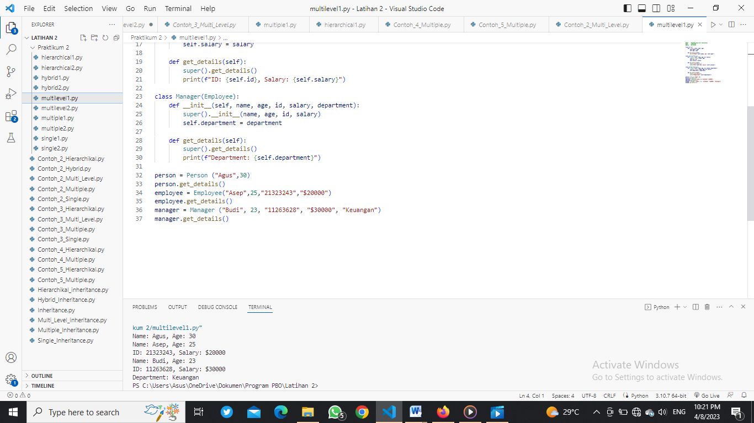

#Nama   : Muhammad Rizqi Nur Ikhsannudin

#Nim    : 210511100

#Kelas  : R3/TIF21C

class Person:

    def __init__(self, name, age):

        self.name = name

        self.age = age

    def get_details(self):

        print(f"Name: {self.name}, Age: {self.age}")

class Employee(Person):

    def __init__(self, name, age, id, salary):

        super().__init__(name, age)

        self.id = id

        self.salary = salary

    def get_details(self):

        super().get_details()

        print(f"ID: {self.id}, Salary: {self.salary}")

class Manager(Employee):

    def __init__(self, name, age, id, salary, department):

        super().__init__(name, age, id, salary)

        self.department = department

    def get_details(self):

        super().get_details()

        print(f"Department: {self.department}")

person = Person ("Agus",30)

person.get_details()

employee = Employee("Asep",25,"21323243","$20000")

employee.get_details()

manager = Manager ("Budi", 23, "11263628", "$30000", "Keuangan")

manager.get_details()

1. Multilevel 2

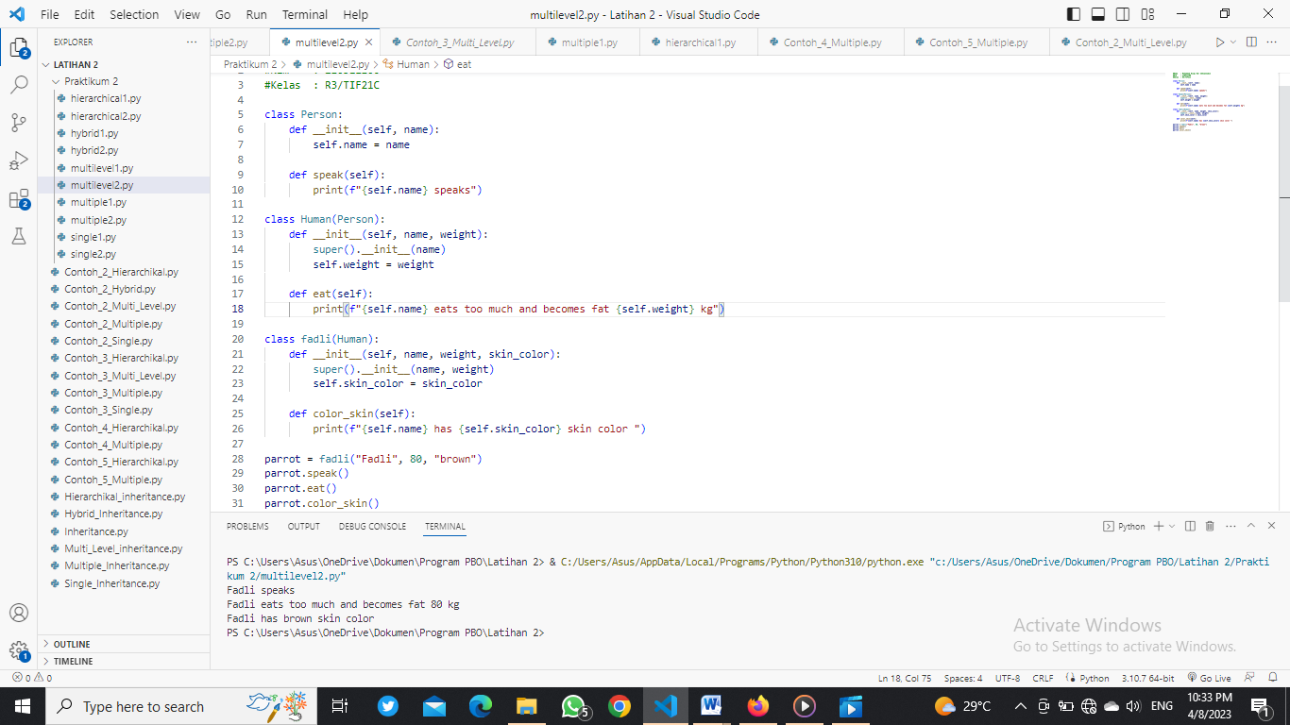

#Nama   : Muhammad Rizqi Nur Ikhsannudin

#Nim    : 210511100

#Kelas  : R3/TIF21C

class Person:

    def __init__(self, name):

        self.name = name

    def speak(self):

        print(f"{self.name} speaks")

class Human(Person):

    def __init__(self, name, weight):

        super().__init__(name)

        self.weight = weight

    def eat(self):

        print(f"{self.name} eats too much and becomes fat {self.weight} kg")

class fadli(Human):

    def __init__(self, name, weight, skin_color):

        super().__init__(name, weight)

        self.skin_color = skin_color

    def color_skin(self):

        print(f"{self.name} has {self.skin_color} skin color ")

parrot = fadli("Fadli", 80, "brown")

parrot.speak()

parrot.eat()

parrot.color_skin()

1. Hybrid 1

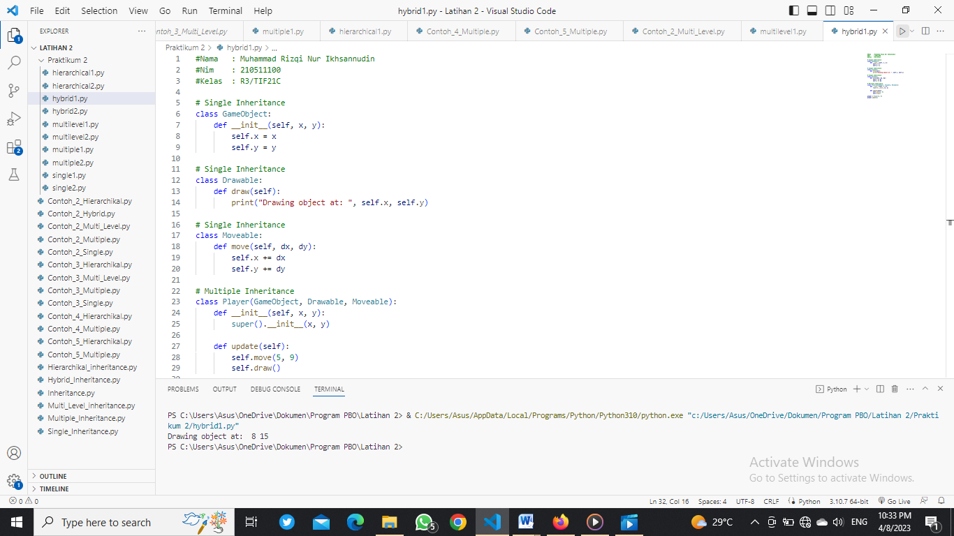

#Nama   : Muhammad Rizqi Nur Ikhsannudin

#Nim    : 210511100

#Kelas  : R3/TIF21C

# Single Inheritance

class GameObject:

    def __init__(self, x, y):

        self.x = x

        self.y = y

# Single Inheritance

class Drawable:

    def draw(self):

        print("Drawing object at: ", self.x, self.y)

# Single Inheritance

class Moveable:

    def move(self, dx, dy):

        self.x += dx

        self.y += dy

# Multiple Inheritance

class Player(GameObject, Drawable, Moveable):

    def __init__(self, x, y):

        super().__init__(x, y)

    def update(self):

        self.move(5, 9)

        self.draw()

player = Player(3, 6)

player.update()

1. Hybrid 2

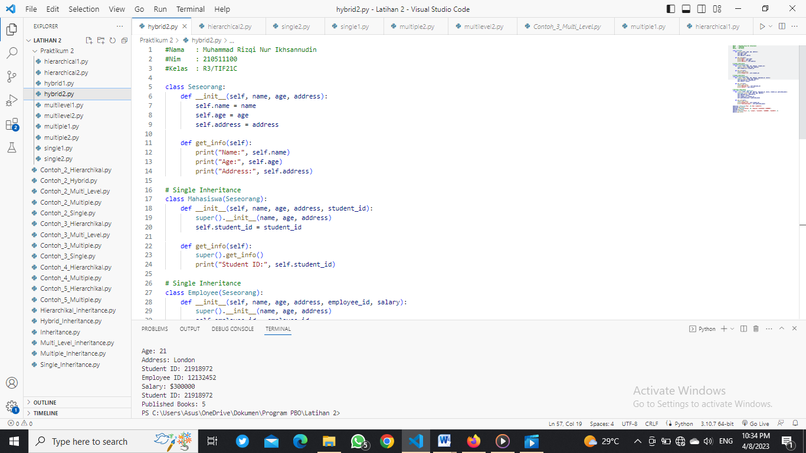

#Nama   : Muhammad Rizqi Nur Ikhsannudin

#Nim    : 210511100

#Kelas  : R3/TIF21C

class Seseorang:

    def __init__(self, name, age, address):

        self.name = name

        self.age = age

        self.address = address

    def get_info(self):

        print("Name:", self.name)

        print("Age:", self.age)

        print("Address:", self.address)

# Single Inheritance

class Mahasiswa(Seseorang):

    def __init__(self, name, age, address, student_id):

        super().__init__(name, age, address)

        self.student_id = student_id

    def get_info(self):

        super().get_info()

        print("Student ID:", self.student_id)

# Single Inheritance

class Employee(Seseorang):

    def __init__(self, name, age, address, employee_id, salary):

        super().__init__(name, age, address)

        self.employee_id = employee_id

        self.salary = salary

    def get_info(self):

        super().get_info()

        print("Employee ID:", self.employee_id)

        print("Salary:", self.salary)

# Multiple Inheritance

class Penulis(Employee, Mahasiswa):

    def __init__(self, name, age, address, employee_id, salary, student_id, published_books):

        Seseorang.__init__(self, name, age, address)

        self.employee_id = employee_id

        self.salary = salary

        self.student_id = student_id

        self.published_books = published_books

    def get_info(self):

        super().get_info()

        print("Student ID:", self.student_id)

        print("Published Books:", self.published_books)

mahasiswa = Mahasiswa("Max", 30,"USA","21065778")

mahasiswa.get_info()

employee = Employee("Rocky", 20, "England","126238282","$500000")

employee.get_info()

penulis = Penulis("Vivi", 21, "London", "12132452", "$300000", "21918972", 5)

penulis.get_info()